Curriculum area | Autumn 1 | Autumn 2 | Spring 1 | Spring 2 | Summer 1 | Summer 2
RE | Creation and covenant | Prophecy and promise | Galilee to Jerusalem | Desert to Garden | To the end of the Earth | Dialogue and encounter
English | Skellig  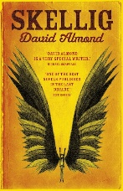  I can write a poem with a repeated verse  I can write a setting description of the garage  I can write a suspense narrative: A prequel- how did Skellig get to the garage? | A Christmas Carol  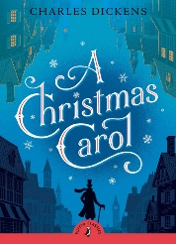  I can write a playscript  I can write a newspaper report  I can write a biography about Charles Dickens | Who Let the Gods out?  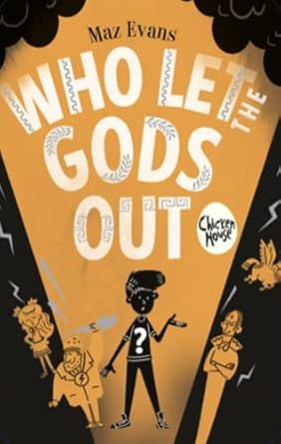  I can write instructions- how to operate a fictional mode of transport  I can write a letter  I can write a character description- modernise a Greek God | Varmints  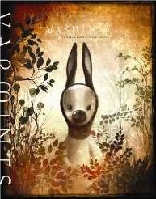  I can write a narrative using film as a stimulus  I can write a newspaper report about a local environmental issue | Shackleton’s journey  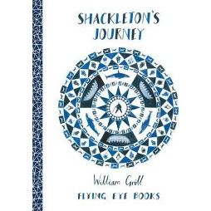  I can write a letter to apply for a place on a ship  I can write a newspaper report  I can write a non-chronological report about Ernest Shackleton | Cosmic  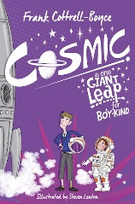  I can write an argument- When is it ok to tell a lie?  I can write a persuasive text: Visitor leaflet for a theme park  I can write a non-chronological piece linked to space
SPaG | Capital letters  Relative pronouns  Commas for parenthesis  Relative clauses  Brackets  Commas to change meaning | Dashes for parenthesis  Modal verbs  Suffixes ate, ise and ify  Punctuating speech  Adjectives or adverbs | Relative clauses  Word classes  De, dis and mis prefixes  Verb forms  Past perfect progressive | Present perfect progressive  Word classes  Subordinate clauses  Apostrophes for plural possessions  Speech punctuation | Clauses  Apostrophes for possession  Identifying verb forms | Missing apostrophes  Standard English  Missing punctuation
Maths | - Place value  - Addition and subtraction  - Multiplication and division | - Fractions | - Multiplication and division  - Fractions | - Decimals and percentages  - Perimeter and area  - Statistics | - Shape  - Position and direction | - Decimals  - Negative numbers  - Converting units  - Volume
Science | Forces | Properties of materials | Space | British Science Week | Living things & their habitats | Animals including humans
Geography | North America- The Rockies  Where is North America?  What is it like? |  | World trade and renewable energy  Why do people trade? |  | Volcanoes and earthquakes  Why do earthquakes occur?
History |  | What were the main changes that took place during this time?  Life in Victorian Britain |  | How shall we tell the story of the first Black people in Britain? |  | What comparisons can we make between Benin and Anglo Saxons, and the Normans?
Art |  | Drawing- depth, emotion and movement  I can explore mark making for showing depth, emotion and movement to portray differing emotions | Painting and mixed media- portraits  I can investigate self-portraits by a range of artists; use photographs as a starting point for developing ideas | Craft and design- architecture  I can investigate the built environment through drawing and printmaking; explore the work of architect Zaha Hadid
Design & technology | Mechanical systems- gears and pulleys  I can conduct market research surrounding an eco-gadget bike to inspire a design criterion |  |  |  | Structures- bridges  I can test and analyse various types of bridges to determine their strength and stability | Cooking and nutrition- developing a recipe  I can learn a simple bolognaise recipe and adapt it to improve nutritional content
Music | Composition notation | Blues | South and West Africa | Compositions to represent the festival of colour (Holi) | Looping and remixing | Musical theatre
Computing | Computing systems and networks- systems and searching | Creating media- video production | Programming A- selection in physical computing | Data and information- flat file database | Creating media- introduction to vector graphics | Programming- selection in quizzes
French | French festivals  Numbers beyond 100 | Family and friends  My home | Colours  Animals  Food | Calendar  Clothing  Shopping | Holidays and celebrations  Towns and cities | Weather and seasons  Sports & hobbies  School
PE | Netball  Dance (dance coach) | Basketball  Dance (dance coach) | Fitness  Rugby (rugby coaches)  Cricket (cricket coaches) | Football  Gymnastics  swimming | Tennis  Athletics | Tag rugby  Rounders  Dance (dance coach)
RSHE |  | Created and loved by God (religious understanding)  Calming the storm  Is God calling You? | Created to love others (personal relationships)  Under pressure  Consent  Self-talk | Created to love others (keeping safe)  Sharing  Cyber bullying  Types of abuse  Impacted lifestyles  Making the right choices  Giving assistance | Created to live in community (religious understanding)  The trinity  Catholic social teaching | Created to live in community (living in the wider world)  Reaching out
PSHE | Keeping and staying safe | Keeping and staying healthy | Growing and changing | Being responsible | Feelings and emotions | Online safety
British values | Democracy | Rule of Law | Respect | Tolerance | Individual liberty
Curriculum enhancements | Shrek the Musical- Edinburgh  Kalpesh- Colour run  Great Athletes ‘sportivator’ workshop  Centenary mass service  Godly Play workshop delivered by Mrs Wright | M&M Productions- A Christmas Carol  Cookery and nutrition workshop at St Joseph’s Catholic Primary School  Advent service  Maths escape room  STEM workshop- music | Space workshop  Mass service  Holocaust Memorial Day  Lent service | Bike ability L2  World Book Day  STEM workshop- cyber fairy tales | World Art Day  Reservoir visit | M&M Productions- Pinocchio  Muncaster residential

