English Long-Term Plan
 | Autumn 1 | Autumn 2 | Spring 1 | Spring 2 |  | Summer 1 |  |  | Summer 2
Nursery
(2s)
Topics | All About Me! | Light and Dark | People Who Help Us | Animals |  | Growing |  |  | Seaside
 | 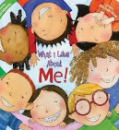  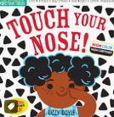 | 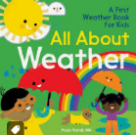  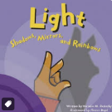  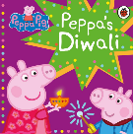 | 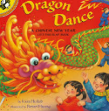  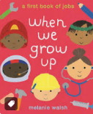  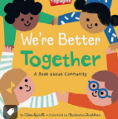 | 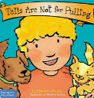  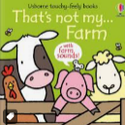  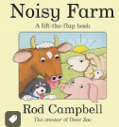 |  | 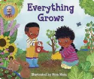  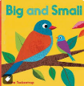 |  |  | 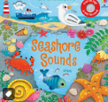  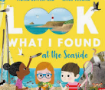
Poetry Basket  Poems/ rhymes in red chosen by school/ school’s poetry spine | Things I Can Do  Down is the Earth  All About Me  Bath Time  Many Things  Tommy Thumb  Happy and You Know it…  Head, Shoulders, Knees and Toes | Twinkle, Twinkle, Little Star  Hey Diddle, Diddle  Mr Moon  Fireworks song sang to the tune of ‘The Wheels on the Bus’ (See shared drive)  A Trillion Stars  Nativity – songs | Pat a Cake  Wheel on the Bus  Old Mc Donald had a Farm  Mrs Cow  Grand Old Duke of York  Humpty Dumpty  An Elephant | Houses  Owl  Wild Beast by Evaleen Stein  Tadpole  Rabbit  Snail  Roar says the lion |  | A Little Seed  Little Bo Peep  Old Mc Donald had a Farm  Jack and Jill went Up the Hill  I’m a Little Teapot  A Sailor went to Sea |  |  | A Grain of Sand  Going to the Seaside  Holiday  Ice Cream  Seashells  The Tide  A Sailor went to Sea Sea Sea
Nursery
Pre-school (3s)
Topics | All About Me! | Light and Dark | People Who Help Us | Animals |  | Growing |  |  | Seaside
Story Dough  A simple, yet powerful way to add the skills of language, fine motor skills, mark making and imagination.  Our ‘Story Dough’ sessions are set around a quality, language rich text. | 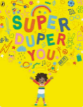  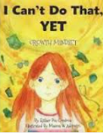 | 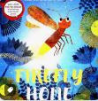  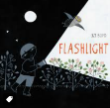 | 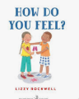  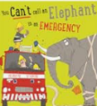 | 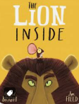 |  | 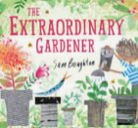  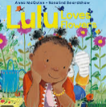 |  |  | 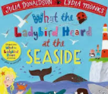  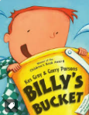
Non-fiction  Texts to supplement vocabulary and development |  |   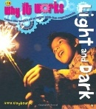 | 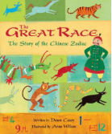  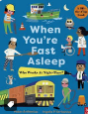 | 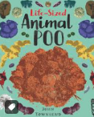 |  | 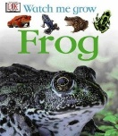
Poetry Basket  Poems/ rhymes in red chosen by school/ school’s poetry spine | Things I Can Do  Down is the Earth  All About Me  Bath Time  Many Things  Tommy Thumb  Happy and You Know it…  Head, Shoulders, Knees and Toes | Twinkle, Twinkle, Little Star  Hey Diddle, Diddle  Mr Moon  Fireworks song sang to the tune of ‘The Wheels on the Bus’ (See shared drive)  A Trillion Stars  Nativity – songs | Pat a Cake  Wheel on the Bus  Old Mc Donald had a Farm  Mrs Cow  Grand Old Duke of York  Humpty Dumpty  An Elephant | Houses  Owl  Wild Beast by Evaleen Stein  Tadpole  Rabbit  Snail  Roar says the lion |  | A Little Seed  Little Bo Peep  Old Mc Donald had a Farm  Jack and Jill went Up the Hill  I’m a Little Teapot  A Sailor went to Sea |  |  | A Grain of Sand  Going to the Seaside  Holiday  Ice Cream  Seashells  The Tide  A Sailor went to Sea Sea Sea
Reception
Topics | Where do I belong? | Celebrations | Traditional Tales | Journeys |  | Life Cycles |  |  | Hot and Cold (Climate Change)
Reading for Pleasure  Quality texts to enhance the children’s vocabulary/ language | 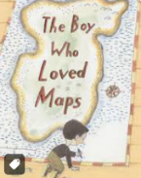  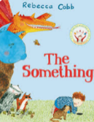  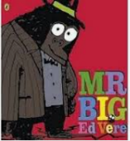 | 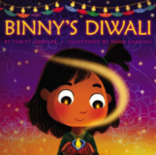  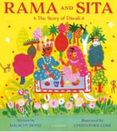 | 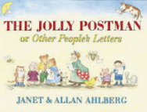  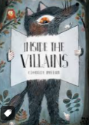 | 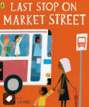  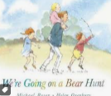  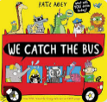 |  | 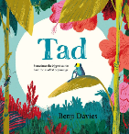  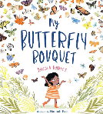 |  |  | 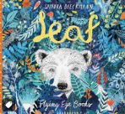  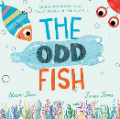
Non-Fiction to supplement vocabulary and language development | 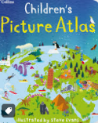  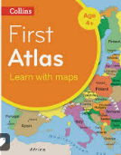 | 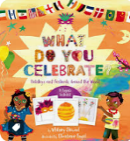 |  | 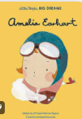 |  | 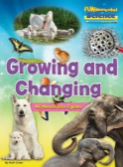  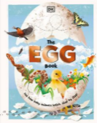 |  |  | 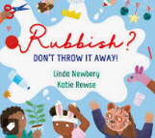
Drawing Club  Drawing Club is about the development of fine motor to add the detail, the extension of vocabulary. It further develops how children can talk confidently, using new vocabulary, listening, sharing ideas, having conversation back and forth, collaborating respecting and helping one and other. | Not Now Bernard – David Mc Kee  Little Red Hen- Paul Galdone  Wacky Races  What’s in the Witches Kitchen- Nick Sharratt  The Magic Porridge Pot – Vera Southgate  Mr Benn Zookeeper | Pirate Pete – Nick Sharratt  Chicken Licken  Roadrunner  The Hairy Toe – Daniel Postgate  Goldilocks  Popeye | A Dark, Dark Tale by Ruth Brown  The Gingerbread Man  Pink Panther – Season 1 Episode 1  Je M’Habille et…Je Te Croque  The Three Little Pigs  Trapdoor Breakfast | Room on the Broom – Julia Donaldson  Hansel and Gretel  Bat Fink: The Short Circuit Case  Penguin – Polly Dunbar  White Hen and the Fox  The Magic Roundabout - Bubbles |  | We’re Going on a Bear Hunt (revisiting)  Michael Rosen  The Billy Goats Gruff  Willo’ the Wisp- The Thoughts of Moog  Would you Rather – John Burningham  Jack and the Beanstalk  Captain Pugwash – Monster Ahoy |  |  | The Giant Jam Sandwich – John Vernon Lord  The Ugly Duckling  Farmer Duck – Nick Wadell  The Tiger who came for Tea – Judith Kerr  Where the Wild Things Are- Maurice Sendak  Dear Zoo- Rod Campbell
Poetry Basket  Poems / rhymes in red chosen by school / schools poetry spine | Buster the Fly  A Little House  Mice by Rose Fyleman  A Little Shell  The Fox  Five Little Owls | Five Little Pumpkins  Pointy Hat  Who has seen the wind?  A Basket of Apples  Pitter Patter  The Thunderstorm | Hickory Dickory Dock  Popcorn  Shoes  Spring Wind  Rabbit  Alligator Pie | Bees  I have Little Frog  Pancakes  Hungry Birds  Stepping Stones  Crayon Poem |  | Incy Wincy Spider  Leaves are Falling  Monkey Babies- by Irene Rownsley and John Foster  Creepy Crawlies  Caterpillar  Springtime |  |  | 1, 2, 3, 4, 5 Once I Caught a Fish Alive  Rain  Flowers  Digging  Leaves are Green  Raindrops  Icicles
Guided Reading Curriculum
Follow the Monster Phonics Guided Reading Programme, with children grouped according to their reading ability. Each group receives three 15-minute Guided Reading sessions per week, using colour-coded, decodable books mapped across 10 structured progression stages to develop reading fluency, accuracy and confidence.
Children focus on the same book across all three sessions, allowing them to develop familiarity with the text and apply their phonics knowledge to increasingly fluent reading. Books are matched to explicit phonics stages and provide a clear progression from early letter–sound blending towards increasingly independent reading.
Year 1
Topics | Space | Seasons | Friendships/ Exploring emotions | Growth |  |  | Africa |  | Adventure
Writing Curriculum
 | 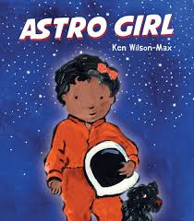 | 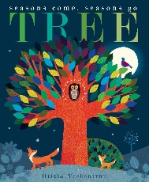 | 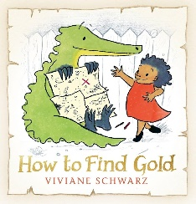 | 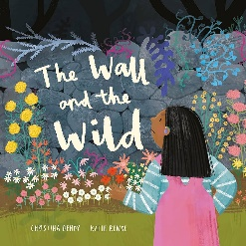 |  |  | 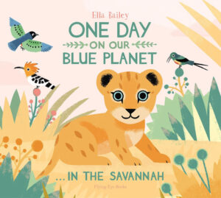 |  | 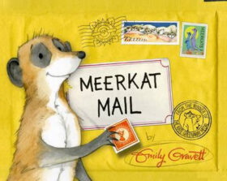
 | Create commands  Fact-file | Information poster  A diary | Commands to give instructions  Describe sea monster | Journal writing  Description of the wild |  |  | Sequence sentences to form a short narrative  Compose and perform poem |  | Postcard  Non- chronological about meerkats
 | Guided Reading Curriculum
Follow the Monster Phonics Guided Reading Programme, with children grouped according to their reading ability. Each group receives three 15-minute Guided Reading sessions per week, using colour-coded, decodable books mapped across 10 structured progression stages to develop reading fluency, accuracy and confidence.
Children focus on the same book across all three sessions, allowing them to develop familiarity with the text and apply their phonics knowledge to increasingly fluent reading. Books are matched to explicit phonics stages and provide a clear progression from early letter–sound blending towards increasingly independent reading.
Reading for Pleasure  Quality texts to enhance the children’s vocabulary/ language | 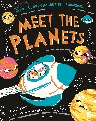  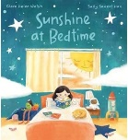  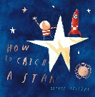 | 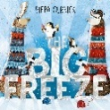  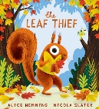  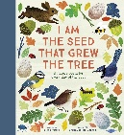 | 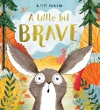  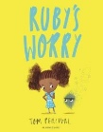 | 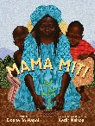  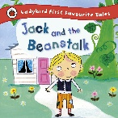 |  |  | 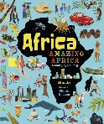  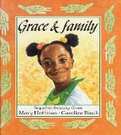 |  | 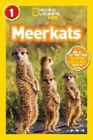  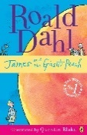
Year 2
Writing Curriculum
 | 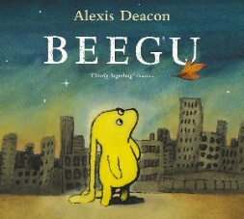 | 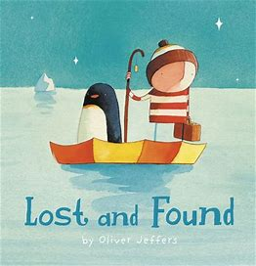 | 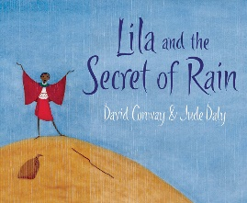 | 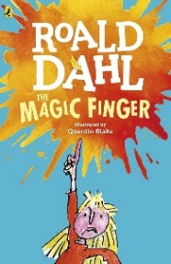 |  |  | 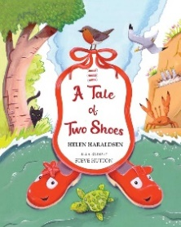 |  | 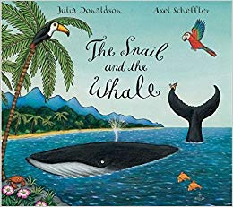
 | Character description  Poem  A letter—A farewell to Beegu | A diary  Narrative  Non-chronological report | A diary  Non-chronological report Setting description | Character description  A persuasive letter  A diary |  |  | Description - shoes  Instructions |  | Narrative  Newspaper report
 | Guided Reading Curriculum
Follow the Monster Phonics Guided Reading Programme, with children grouped according to their reading ability. Each group receives three 15-minute Guided Reading sessions per week, using colour-coded, decodable books mapped across 10 structured progression stages to develop reading fluency, accuracy and confidence.
Children focus on the same book across all three sessions, allowing them to develop familiarity with the text and apply their phonics knowledge to increasingly fluent reading. Books are matched to explicit phonics stages and provide a clear progression from early letter–sound blending towards increasingly independent reading.

Reading for Pleasure  Quality texts to enhance the children’s vocabulary/ language | 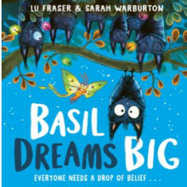  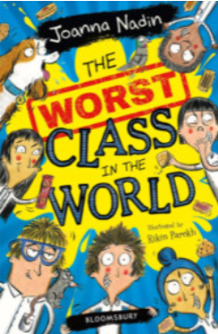 | 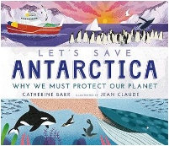  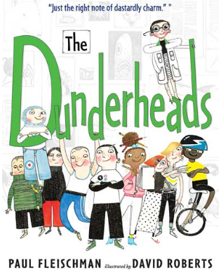 | 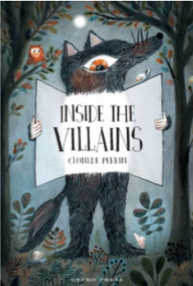  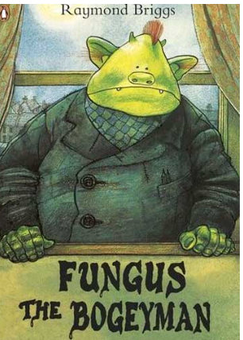 | 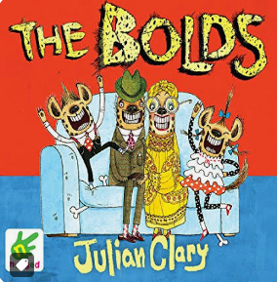 |  |  | 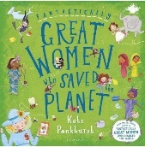  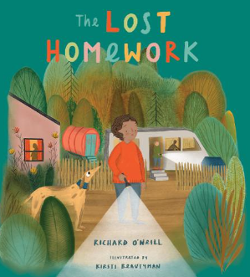 |  | 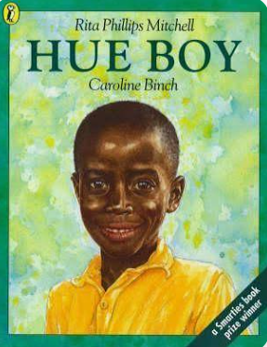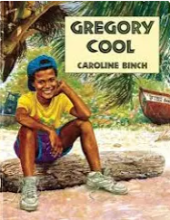
Year 3
Writing Curriculum
 | 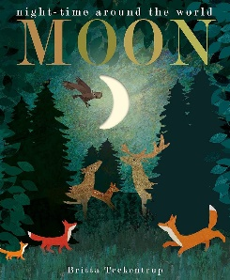 | 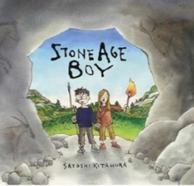 | 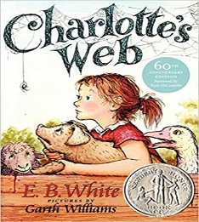 | 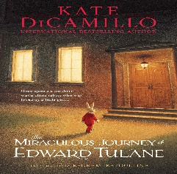 |  |  | 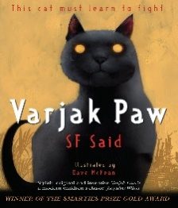 |  | 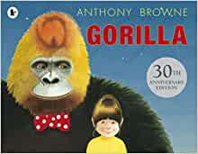
 | Non-chronological report  List poem  Adventure narrative | Letter  Non-chronological report  Comic strip narrative | Advertisement Persuasive leaflet | Letter  Narrative |  |  | Diary  Setting description  Newspaper report |  | Balanced argument  Poem using alliteration
 | Reading Curriculum
 | The Owl Who Was Afraid of the Dark- Jill Tomlinson  The Dark- Lemony Snicket  The Journey Home- Frann Preston- Gannon  The Owl and the Pussy Cat – Edward Lear | The Wild Way Home- Sophie Kirtley  Iron Man- Ted Hughes  24 Hours in the Stone Age- Lan Cook | The Hodgeheg – Dick King-Smith  Country Show advertisement  Zoo Leaflet/ Theme Park Leaflet | The Giving Tree – Shel Silverstein  The Velveteen Rabbit – Margery Williams |  |  | The Wild Robot – Peter Brown  The Last Wild – Piers Torday |  | To the Countryside from Poems Aloud.  Willy and the Cloud – Anthony Browne
Year 4
Writing Curriculum
 | 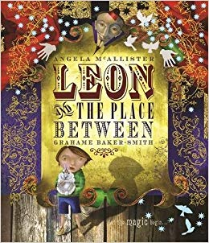 | 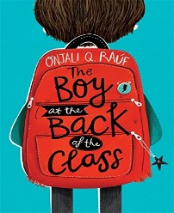 | 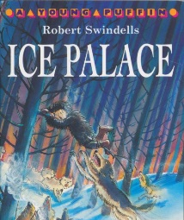 | 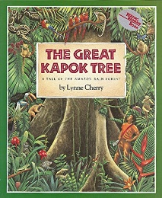 |  |  | 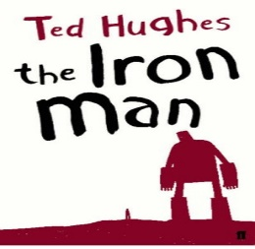 |  | 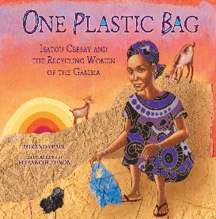
 | Description  List poem  Playscript  Narrative | Information PowerPoint  Newspaper report  Letter | Setting description Information leaflet  Letter | Free verse poem Argument  Persuasive letter |  |  | Diary  Poem  Narrative |  | Non-chronological report  Instructions  Poem- Haiku
Reading Curriculum
 | The Lion, the Witch and the Wardrobe – C.S. Lewis  The Miraculous Journey of Edward Tulane – Kate DiCamillo  (revisit extract from Year 3 text) | Refugee information text  Newspaper reports  Letters from/  about refugees | The Snowman – Raymond Briggs  A Bear Grylls Adventure: The Blizzard Challenge – Bear Grylls and Emma McCann | The Shaman’s Apprentice- Lynne Cherry  We Are Water Protectors – Carole Lindstrom  The Promise- Nicola Davies  The Last Tree – Emily Haworth-Booth |  |  | The Tin Forest – Helen Ward  The Explorer- Katherine Rundell  The Wild Robot – Peter Brown |  | The Last Tree- Emily Haworth Booth  Ada’s Violin- Susan Hood
Year 5
Writing Curriculum
 | 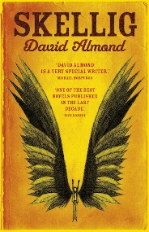 | 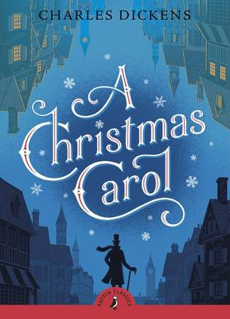 | 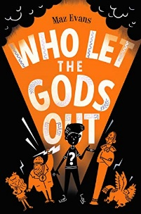 | 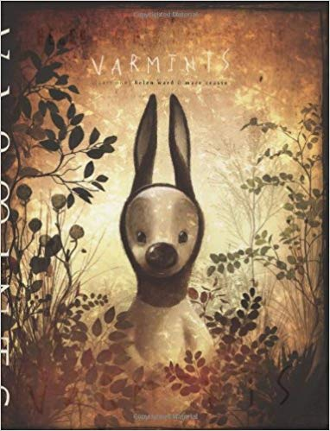 |  |  | 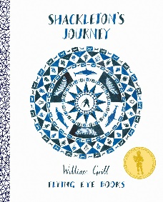 |  | 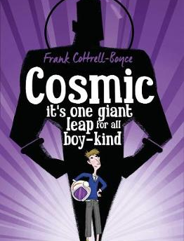
 | Repeating verse poem  Setting description  Suspense narrative | Playscript  Newspaper report Biography | Instructions  Letter  Character description | Narrative  Newspaper report |  |  | Letter  Newspaper report Non-chronological report |  | Argument  Persuasive text  Non-chronological report
Reading Curriculum
 | The Graveyard Book- Neil Gaiman  The Highwayman- Alfred Noyes  The Viewer- Shaun Tan  The Nowhere Emporium- Ross MacKenzie | Oliver Twist- Charles Dickens  The Selfish Giant- Oscar Wilde  The Giant’s Necklace- Michael Morpurgo  Biography Charles Dickens  The Signalman- Charles Dickens | Percy Jackson and the Lightning Thief – Rick Riordan  Pandora's Box – Greek myth  The Odyssey – Homer, adapted retelling  The Firework-Maker's Daughter – Philip Pullman  Greek mythology: Athena/Zeus/Poseidon | The Lost Words – Robert Macfarlane & Jackie Morris  Floodland – Marcus Sedgwick  The Iron Woman – Ted Hughes  Running on Empty – S. A. Bodeen  The Boy Who Harnessed the Wind – William Kamkwamba  Current Environmental News Article |  |  | Ice Trap! – Meredith Hooper  The Call of the Wild- Jack London  The Wolf Wilder- Katherine Bundell  The Last Bear- Hannah Gold |  | The Jamie Drake Equation – Christopher Edge  Hidden Figures: The True Story of Four Black Women and the Space Race – Margot Lee Shetterly  The Infinite Lives of Maisie Day – Christopher Edge  The Skylark's War – Hilary McKay  George's Secret Key to the Universe – Lucy & Stephen Hawking
Year 6
Writing Curriculum
 | 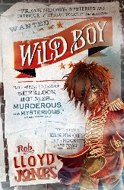 | 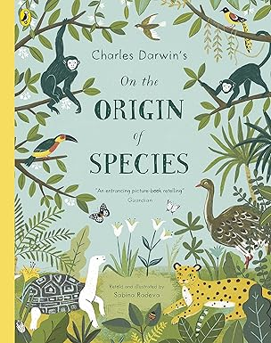 | 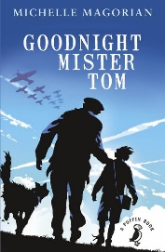 |  |  |  | 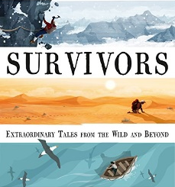 | 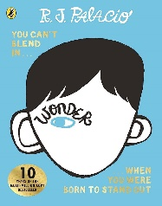
 | Diary  Balanced argument  Suspense narrative | Biography  Discovery narrative | Free verse poem  Playscript  Explanation text |  | Setting description Third person narrative |  | Information text Formal letter  Non-chronological report | Emotive speech  Diary  Letter
Reading Curriculum
 | The Elephant Man – Michael Howell & Peter Ford  The One and Only Ivan – Katherine Applegate  The Butterfly Lion – Michael Morpurgo  The Sign of Four – Arthur Conan Doyle  The Landlady – Roald Dahl | Charles Darwin: The Voyage of the Beagle  Dawrin’s Dragons- Linsay Galvin  Mary Anning: Fossil Hunter  Adventures of a Young Naturalist- David Attenborough  The Hound of the Baskervilles- Arthur Coman Doyle | Tom Palmer- WWII fiction extracts  What are we Fighting For? Brian Moses  When the Sky Falls- Phil Earle  Shrapnel’s Boy- Geoffrey Malone |  | Focus on reading skills to support Year 6 during SATs. Continue to carry out additional work on Goodnight Mister Tom |  | The Girl Who Fell from the Sky - factual account of Juliane  Touching the Void- Joe Simpson | Shakespeare Unit  A Midsummer Night’s Dream  The Tempest  Macbeth  Romeo and Juliet

