Cumberland 0-19 Service
Cumbria House
Botchergate
Carlisle
CA1 1RD
T: 03003049029
E: hdft.spoc0-19cumberland@nhs.net
October 2025

Dear Parent/Carer,
Height and weight checks for children of Reception age (born 1st September 2020 – 31st August 2021) and of Year 6 age (born 1st September 2014 – 31st August 2015)

Every year in England, school children in reception and year 6 have their height and weight checked at school. This is called the National Child Measurement Programme (NCMP). The checks are carried out by trained health and care providers. Children are measured fully clothed, except for their coats and shoes, away from other pupils. You can watch the NCMP process animation. The animation explains the process of the NCMP and why it is important. It will guide you through what it involves, how your child’s data is collected and processed and what it will be used for.
Why do we need to measure children?
Children’s height and weight measurements are collected to build an understanding of how children are growing. The information from the NCMP is used by local councils and the NHS to plan the provision of health and leisure services for families to promote healthier growth in children.
Your child’s class will take part in this year’s programme.
What information is collected and why
Your child’s height, weight, age, sex, and date of birth are collected to calculate their weight category (also known as child body mass index).
Your child’s ethnicity and address are collected to monitor differences in child growth and weight between ethnic groups, where children live and their backgrounds.
Your child’s name, date of birth and NHS number are collected to link their measurements from reception and year 6 to other information from health and education records held by NHS England, the Department of Health and Social Care and the Department for Education, where it is legal to do so.

Information about how personal information and data is collected and stored
You can read more about how the Department of Health and Social Care collects, stores and uses your child’s information and data in the National Child Measurement Programme privacy notice.
You can read more about how NHS England collects, stores and uses your child’s information and data at National Child Measurement Programme (NCMP): GDPR information.
At the NHS England National Child Measurement Programme webpage you can read more about:
- taking part in the programme
- how your data is collected
- how your data is used
You can read more about how Cumberland Council and Harrogate & District Foundation Trust collects, stores and uses your child’s information at Services privacy notices | Cumberland Council and Privacy Notices - Harrogate and District NHS Foundation Trust.
How you can withdraw your child from participating in the NCMP
If you are happy for your child to be measured, you do not need to do anything.
If you do not want your child’s height and weight to be measured, or your child has a medical condition that affects their height or weight, please let us know using the opt out form in the link below.
If your child is unable to participate due to being unable to stand unaided please use the opt out form in the link below.
Children will not be made to take part on the day if they do not want to.
How is a child’s mental health and wellbeing considered in the NCMP
The wellbeing of children and families is very important to the programme. Measurements are conducted in a sensitive way, away from other children. Individual feedback is not shared with your child or their school.
Following the screening, we will only be in touch if we have any health-related observations to discuss regarding your child.
If you are concerned about your child’s growth, weight, body image or eating patterns, seek further support from a public health nurse or GP.
Opt out
If you do not wish for your child to participate in this screening service please click on this link: https://cumbria.childscreening.co.uk/Forms/ChildScreeningOptOut

Further information
You can find information and fun ideas to help your kids stay healthy at the NHS Better Health: healthier families webpage Easy ways to eat well and move more.
Another way to help maintain a balanced diet and physical activity for your family is the NHS Healthy Steps email programme. Sign up for the 8-week Healthy Steps emails and you will be sent lots of low-cost easy tips, fun games, healthy swaps and tasty recipes on a budget. You can sign up to NHS healthy steps by scanning the QR code or visiting healthysteps.uk.
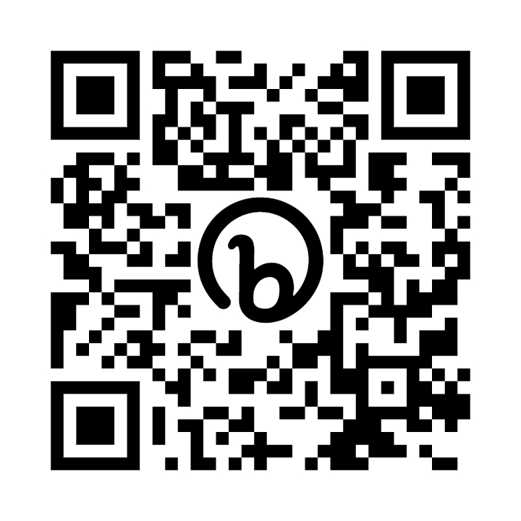
You can find further information about the NCMP at The National Child Measurement Programme NHS webpage https://digital.nhs.uk/services/national-child-measurement-programme

Yours Sincerely

Cumberland 0-19 Public Health Screening Team

Contact Us

T: 0300 304 9029

E: hdft.spoc0-19cumberland@nhs.net
S: For all the latest news, follow us on social media: https://www.facebook.com/growinghealthycumberland
A: You can download our Growing Healthy 0-19 App on the QR code below or following the steps from Download Our App | HDFT Childrens Health Service


